**OpenSimMPLS**

v2.0



Quick user guide

June 2018

Manuel Domínguez Dorado

[opensimmpls@manolodominguez.com](mailto:opensimmpls@manolodominguez.com)

<https://opensimmpls.manolodominguez.com>

Content

Introduction 4

Requirements 4

Starting OpenSimMPLS v2.0 4

Main simulator interface 4

Scenario menu 5

View menu 5

Help menu 6

Scenario window 6

Step 1. Scenario design 7

Traffic sinks insertion and configuration 7

Traffic generators insertion and configuration 8

LERs insertion and configuration 10

Active LERs insertion and configuration 11

LSRs insertion and configuration 13

Active LSRs insertion and configuration 14

Links insertion and configuration 16

Design finishing 17

Design editing 18

Step 2. Scenario information and timing parameters 19

Step 3. Simulation execution 20

Start simulation 21

Understanding the simulation 21

Interacting with the simulation 22

Step 4. Analyzing the simulation 24

Selection of the element to analyze 24

Statistical analysis 25

Exporting charts 25

Contribute 26

Teachers 26

Students 26

Researchers 26

Professionals/developers 26

# Introduction

OpenSimMPLS is a MPLS network simulator, written in Java, portable and Multilanguage. It can simulate:

* Single-domain MPLS networks (use only LERs, LSRs, traffic generators and traffic sinks if you want to simulate this kind of networks).
* Single-domain MPLS networks that support Guarantee of Service (GoS) using active techniques (mix LERs, LSRs, active LERs, active LSRs, traffic generators and traffic sinks, as desired, if you want to simulate this kind of networks).

This guide is a little help so you can take your first steps with the simulator quickly. Therefore it is brief and schematic.

# Requirements

You need to have installed in your operating system:

* Java 8.

And, of course, have downloaded OpenSimMPLS v2.0, which you can do from the project page that you see in the header of this guide.

# Starting OpenSimMPLS v2.0

Once downloaded, run the simulator with the following command:

java -jar openSimMPLS-bin-v2.0.jar

# Main simulator interface

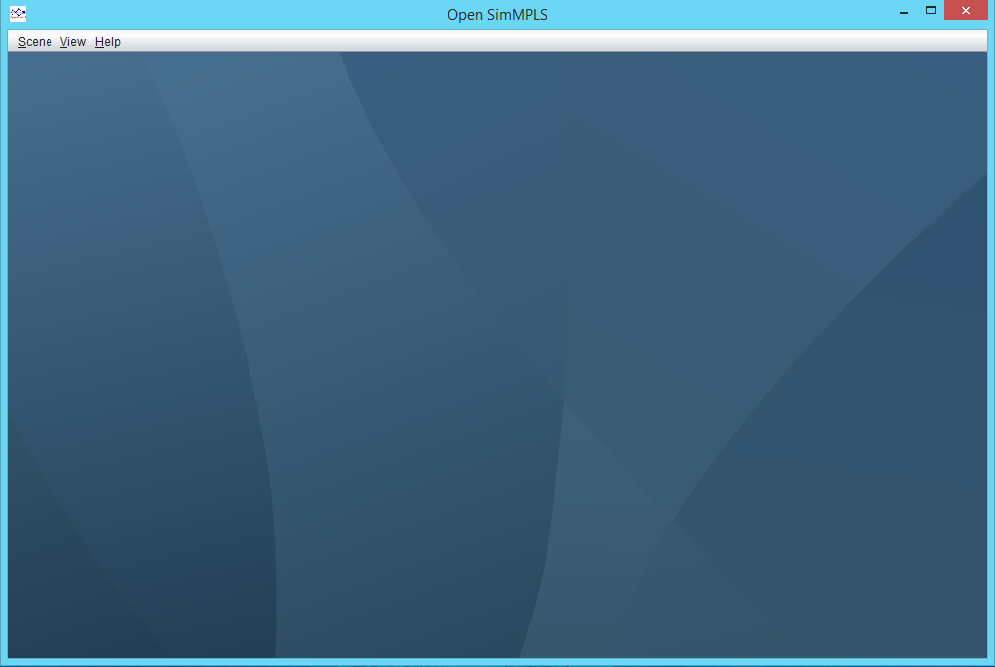

Options to get help

Options to show different scenarios on screen when there is more than one opened

Scenario management

Area where the scenarios will be opened

The initial window of the simulator appears only with a menu of options and a large space within which the different scenarios that are being designed or simulated will be displayed.

OpenSimMPLS allows you to keep more than one scenario open or running simultaneously.

## Scenario menu

Some of the options will only be active if there is a scenario opened.

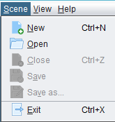

Create a new, empty scenario

Open an existing scenario

Close the scenario that is active

Save the changes in the active scenario

Save the active scenario with the desired name

Close everything and exit from OpenSimMPLS

## View menu

Some of the options will only be active if there is a scenario opened.

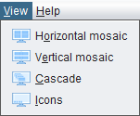

Show all opened scenarios by distributing the horizontal space of the window

Show all opened scenarios by distributing the vertical space of the window

Show all scenarios opened, in cascade.

Show all open scenarios, as icons, in the lower left part of the window

## Help menu

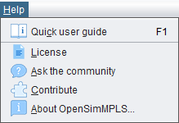

Show the quick user guide (the document you are reading right now)

Show OpenSimMPLS license

Open the OpenSimMPLS site on GitHub to create a new issue (requires you to have a GitHub account).

Open the OpenSimMPLS project on GitHub so that you know the different ways in which you can contribute to improve it

Show information about OpenSimMPLS

# Scenario window

Each scenario has its own window within the simulator. This is where all the action happens and where all the OpenSimMPLS functionality is. Each open scenario is independent of the other open scenarios.

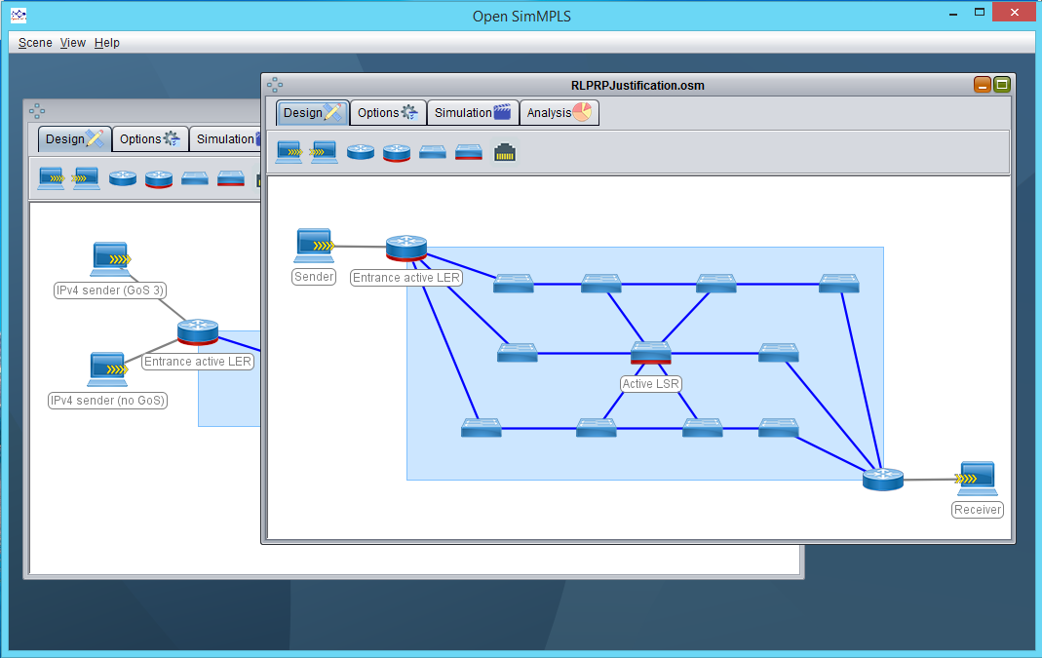

Ventanas de escenarios abiertas

Opened scenario windows

The scenario window has four tabs that will guide you through the simulation process. Follow them in the order in which they appear:

1. **Scenario design.** Configure the topology, the elements, the links and the configuration all of them. It also defines the type of traffic you want to generate and who will receive it.
2. **Options.** Put a title and describe your scenario. In addition, select the duration of the simulation and the grain of it.
3. **Simulation.** Put your scenario to work and interact with the simulation in real time.
4. **Analysis.** Select elements of the topology and see statistical information about them. Observe what has happened throughout the time of the simulation.

## Step 1. Scenario design

To design the scenario, select the Design tab.

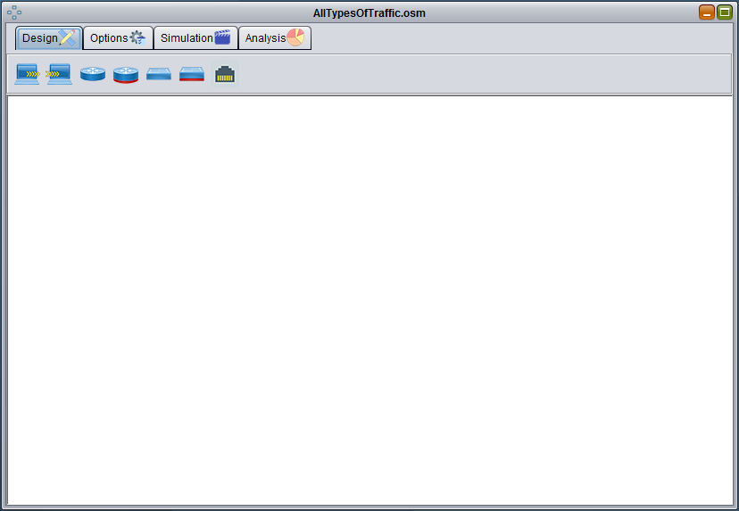

Inserts a link (requires at least two nodes previously inserted)

Inserts an active LSR

Inserts a LSR

Inserts an active LER

Inserts a LER

Inserts a traffic receiver

Inserts a traffic generator (requires at least a traffic receiver previously inserted)

### Traffic sinks insertion and configuration

When we insert a traffic receiver, its configuration window appears, with three tabs: general configuration, quick configuration or advanced configuration (to choose).

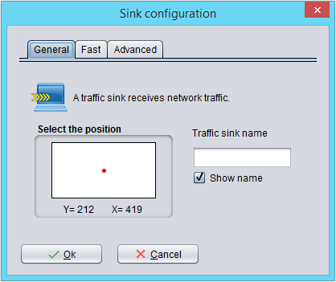

Give the receiver a name, which is not already being used by another previously inserted element

This rectangle represents the scenario window. If you want, select in it where you want the receiver to appear.

Check this box if you want the name to be shown in the simulator

If you want, you can use the quick settings to have something to try if you're in a hurry. Or if you want to configure all the parameters, use the advanced settings. It does not make sense to use both tabs.

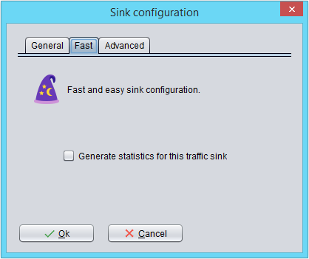

If you later want to have statistical data of this element, select this option (prudently, consume a lot of memory)

Accept and you have already inserted a traffic receiver. Or cancel, if you no longer want to insert it.

In the case of the traffic receiver, the advanced configuration and quick configuration are the same. There is not much to configure.

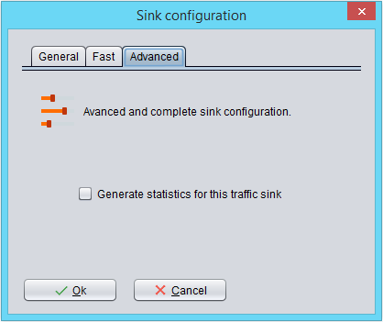

If you later want to have statistical data of this element, select this option (prudently, consume a lot of memory)

Accept and you have already inserted a traffic receiver. Or cancel, if you no longer want to insert it.

### Traffic generators insertion and configuration

When we insert a traffic generator, its configuration window appears, with three tabs: general configuration and quick configuration or advanced configuration (to choose).

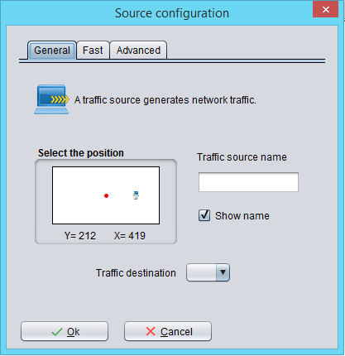

Give the generator a name which is not already being used by another previously inserted element

This rectangle represents the scenario window. If you want, select in it where you want the generator to appear.

Select, from all the traffic receivers that are already inserted, to which of them the traffic will be directed.

Check this box if you want the name to be shown in the simulator

If you want, you can use the quick settings to have something to try if you're in a hurry. Or if you want to configure all the parameters, use the advanced settings. It does not make sense to use both tabs.

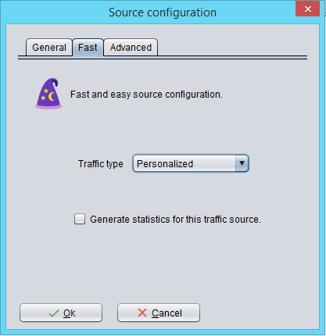

Select what type of traffic, predefined, you want the generator to generate. This will configure everything necessary.

Accept and you have already inserted a traffic receiver. Or cancel, if you no longer want to insert it.

If you later want to have statistical data of this element, select this option (prudently, consume a lot of memory)

In the case of the traffic receiver, the advanced configuration allows defining all aspects of the traffic that you want to generate.

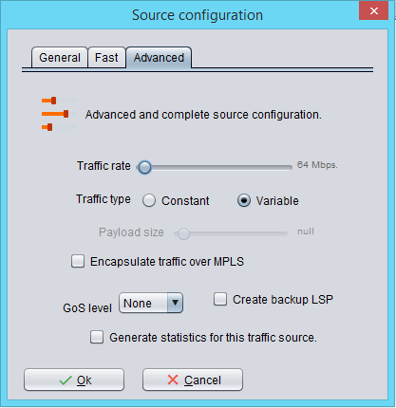

Choose the number of megabits per second you want to generate

You can generate constant traffic (with the size you choose) or variable (following statistics from the Abilene Network).

For constant traffic, select the size of the payload of the packets, in octets.

By default it will generate IPv4 traffic. Check this box if you want to generate MPLS traffic.

You can request that an additional backup LSP be pre-established for traffic by checking this box.

If you later want to have statistical data of this element, select this option (prudently, consume a lot of memory)

Select the level of Service Guarantee (GoS) you want for traffic. Higher level for more important traffic.

### LERs insertion and configuration

When we insert an LER, its configuration window appears, with three tabs: general configuration and quick configuration or advanced configuration (to choose).

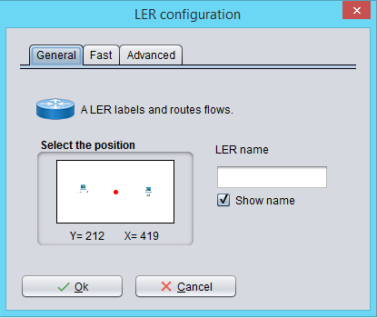

Give the LER a name which is not already being used by another previously inserted element

This rectangle represents the scenario window. If you want, select in it where you want the LER to appear.

Check this box if you want the name to be shown in the simulator

If you want, you can use the quick settings to have something to try if you're in a hurry. Or if you want to configure all the parameters, use the advanced settings. It does not make sense to use both tabs.

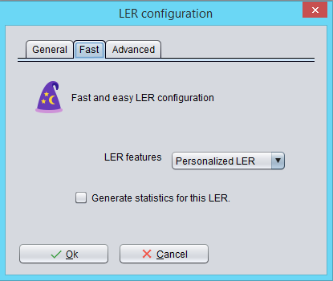

Select what type of LER, predefined. This will configure everything necessary.

Accept and you have already inserted an LER. Or cancel, if you no longer want to insert it.

If you later want to have statistical data of this element, select this option (prudently, consume a lot of memory)

In the case of the LER, the advanced configuration allows defining all aspects of the hardware required.

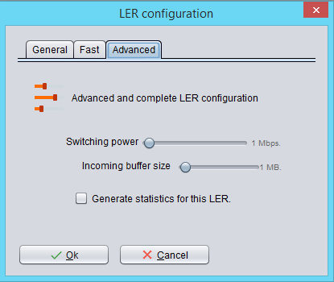

Choose the number of megabits per second that the LER can process

Choose the size of the input buffer of the LER, in Megabytes

If you later want to have statistical data of this element, select this option (prudently, consume a lot of memory)

Accept and you have already inserted an LER. Or cancel, if you no longer want to insert it.

### Active LERs insertion and configuration

When we insert an active LER, its configuration window appears, with three tabs: general configuration and quick configuration or advanced configuration (to choose).

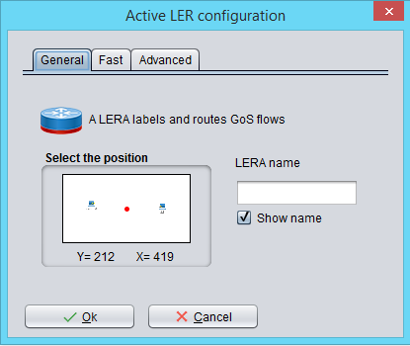

Give the active LER a name which is not already being used by another previously inserted element

This rectangle represents the scenario window. If you want, select in it where you want the active LER to appear.

Check this box if you want the name to be shown in the simulator

If you want, you can use the quick settings to have something to try if you're in a hurry. Or if you want to configure all the parameters, use the advanced settings. It does not make sense to use both tabs.

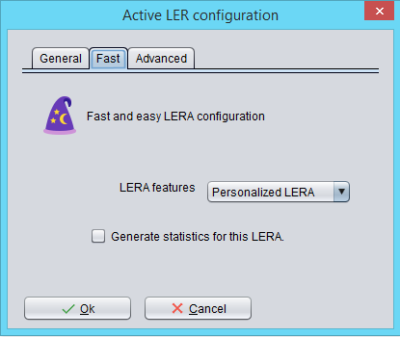

Select what type of LER is active, predefined. This will configure everything necessary.

Accept and you have already inserted an active LER. Or cancel, if you no longer want to insert it.

If you later want to have statistical data of this element, select this option (prudently, consume a lot of memory)

In the case of the active LER, the advanced configuration allows defining all the necessary hardware aspects.

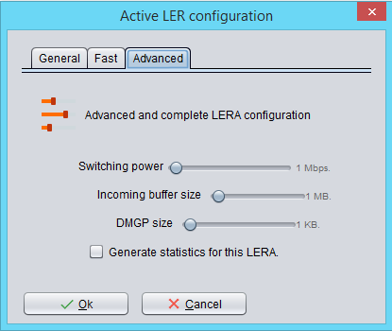

Choose the number of megabits per second that the active LER can process

Choose the size of the input buffer of the active LER, in Megabytes

If you later want to have statistical data of this element, select this option (prudently, consume a lot of memory)

Accept and you have already inserted an active LER. Or cancel, if you no longer want to insert it.

Choose the size of the DMGP in Kilobytes. Larger DMGP allows you to recover more packets locally.

### LSRs insertion and configuration

When we insert an LSR, its configuration window appears, with three tabs: general configuration and quick configuration or advanced configuration (to choose).

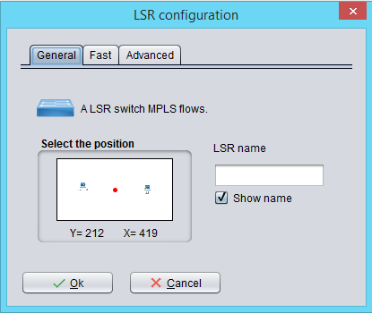

Give the LSR a name which is not already being used by another previously inserted element

This rectangle represents the scenario window. If you want, select in it where you want the LSR to appear.

Check this box if you want the name to be shown in the simulator

If you want, you can use the quick settings to have something to try if you're in a hurry. Or if you want to configure all the parameters, use the advanced settings. It does not make sense to use both tabs.

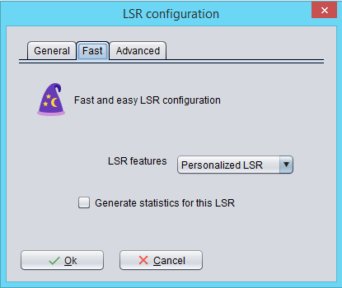

Select what type of LSR, predefined. This will configure everything necessary.

Accept and you have already inserted an LSR. Or cancel, if you no longer want to insert it.

If you later want to have statistical data of this element, select this option (prudently, consume a lot of memory)

In the case of the LSR, the advanced configuration allows defining all aspects of the hardware required.

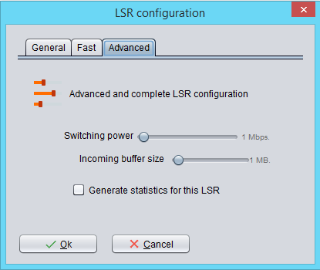

Choose the number of megabits per second that the LSR will be able to process

Choose the size of the LSR input buffer, in Megabytes

If you later want to have statistical data of this element, select this option (prudently, consume a lot of memory)

Accept and you have already inserted an LSR. Or cancel, if you no longer want to insert it.

### Active LSRs insertion and configuration

When we insert an active LSR, its configuration window appears, with three tabs: general configuration and quick configuration or advanced configuration (to choose).

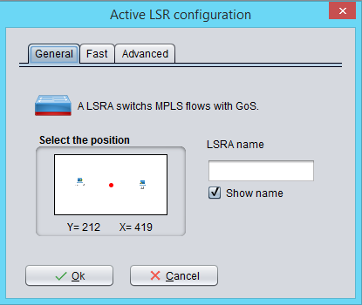

Give the active LSR a name which is not already being used by another previously inserted element

This rectangle represents the scenario window. If you want, select in it where you want the active LSR to appear.

Check this box if you want the name to be shown in the simulator

If you want, you can use the quick settings to have something to try if you're in a hurry. Or if you want to configure all the parameters, use the advanced settings. It does not make sense to use both tabs.

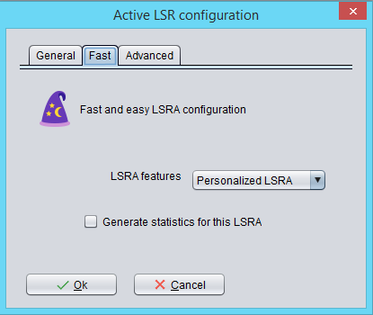

Select which type of LSR is active, predefined. This will configure everything necessary.

Accept and you have already inserted an active LSR. Or cancel, if you no longer want to insert it.

If you later want to have statistical data of this element, select this option (prudently, consume a lot of memory)

In the case of the active LSR, the advanced configuration allows defining all the necessary hardware aspects.

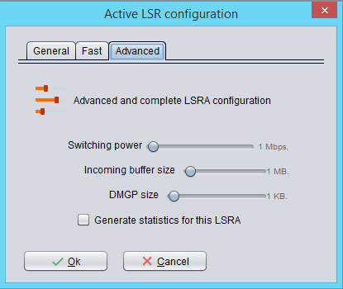

Choose the number of megabits per second that the active LSR can process

Choose the size of the input buffer of the active LSR, in Megabytes

If you later want to have statistical data of this element, select this option (prudently, consume a lot of memory)

Accept and you have already inserted an active LSR. Or cancel, if you no longer want to insert it.

Choose the size of the DMGP in Kilobytes. Larger DMGP allows you to recover more packets locally.

### Links insertion and configuration

When we insert a link, its configuration window appears, with three tabs: general configuration and quick configuration or advanced configuration (to choose).

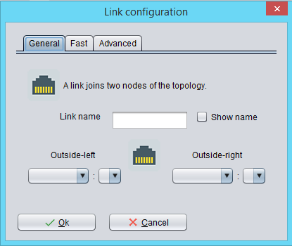

Check this box if you want the name to be shown in the simulator

Give the link a name which is not already being used by another previously inserted element

Here appear the nodes already inserted and with free ports. Select one.

Once the head end is selected, the rest nodes appear here, if they are not already linked with the head end and as long as they have free ports. Select one tail end.

Select which port on the tail end the link will connect to.

Select to which port on the head end the link will connect.

If you want, you can use the quick settings to have something to try if you're in a hurry. Or if you want to configure all the parameters, use the advanced settings. It does not make sense to use both tabs.

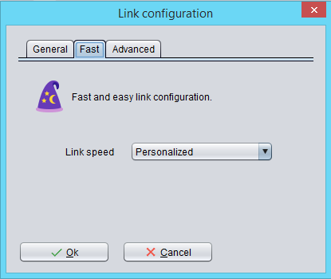

Select which type of LSR is active, predefined. This will configure everything necessary.

Accept and you have already inserted a link. Or cancel, if you no longer want to insert it.

In the case of the active LSR, the advanced configuration allows defining all the necessary hardware aspects.

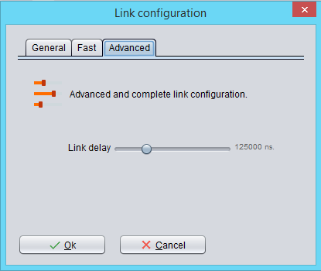

Define the delay, in nanoseconds, that you want the link to have.

Accept and you have already inserted a link. Or cancel, if you no longer want to insert it.

### Design finishing

Repeat the process of inserting elements as many times as necessary until you have designed the desired topology. The following figure shows an example of how a completely designed scenario would look.

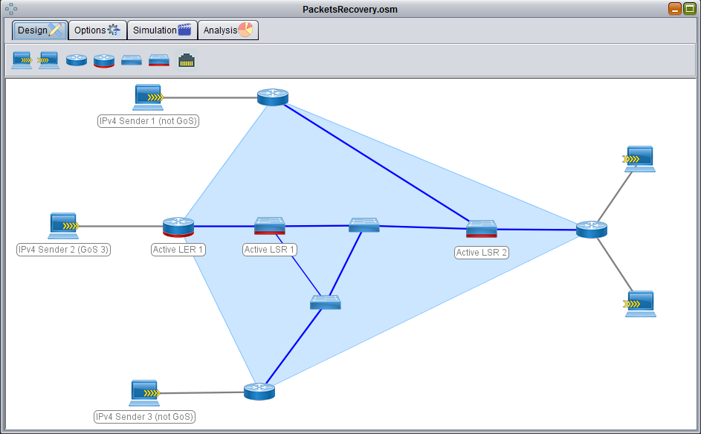

External links to the MPLS domain appear in gray

Internal links to the MPLS domain appear in blue

The LERs, together, determine the MPLS domain, which appears in blue

### Design editing

At any time, the design can be edited: change the settings, delete inserted elements, and so on. For example:

* A right click on an element (node or link) shows options on that element.

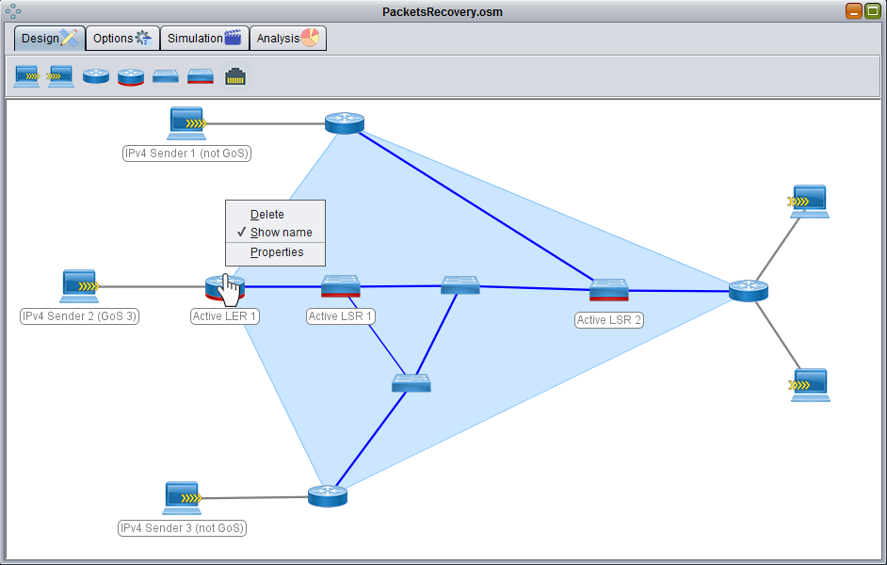

Remove the item If it is a node, it also eliminates the associated links.

Show / hide the item name

Open the element configuration window.

* A right click on the background of the design space shows global options on the design.

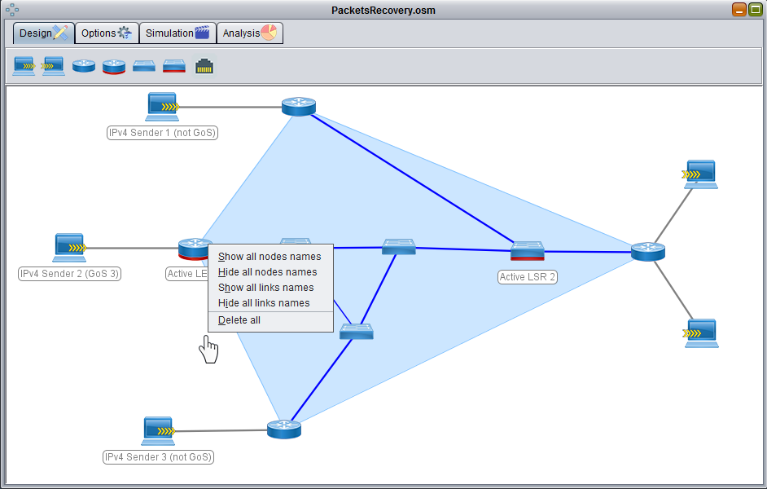

Show the names of all nodes

Hide the names of all nodes

Show the names of all links

Hide the names of all links

Completely eliminates the current design

* You can drag the nodes with the main mouse button to place them where you want.

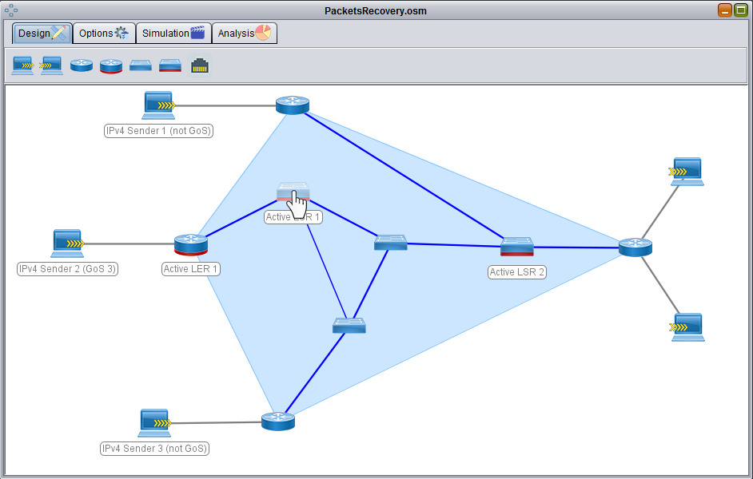

The node appears translucent while you are moving it.

## Step 2. Scenario information and timing parameters

To define the duration and basic data of the scenario, select the "Options" tab. In this tab you can define several aspects such as, for example, data about the scenario (author, title, description) or the duration of the simulation and its granularity.

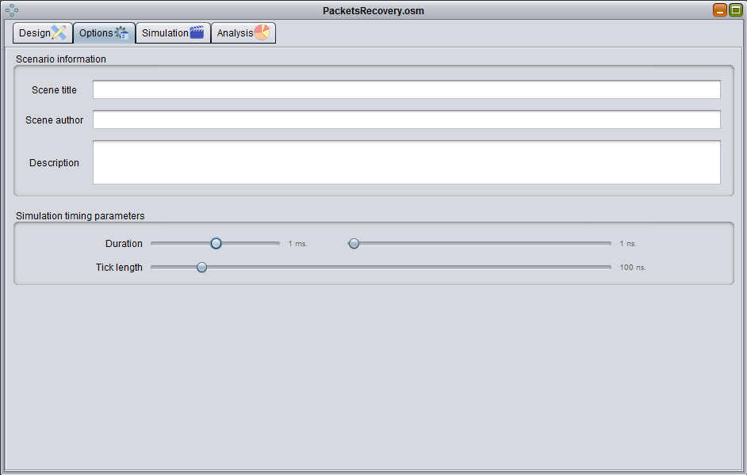

Give your scenario a title

Put your data here (name, surname, email ...).

Describe the scenario. What do you intend to simulate in it?

Choose the duration of the simulation. It will be the sum of the milliseconds and nanoseconds that you choose

The simulation is done through discrete events. The duration of these events is defined in this point. You will not be able to analyze with a finer grain than what you define here. Lower values allow finer simulations (and that consume more resources). Higher values, the opposite. The smallest possible value is the smallest delay of the links in the scenario you designed.

## Step 3. Simulation execution

When everything is configured in the "Design" and "Options" tabs, it is usual to go to the "Simulation" tab, where the designed scenario can be put into operation.

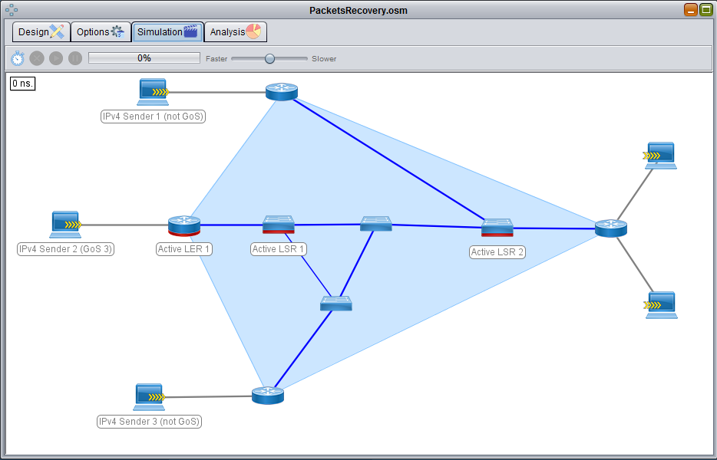

Accelerates or slows down the simulation

Show the progress of the simulation

Pause the simulation

Resumes the simulation if it is paused

Stops/finishes the simulation

Start the simulation

### Start simulation

When the simulation starts, all the elements of the scenario begin to work in unison with the parameters that have been configured for them.

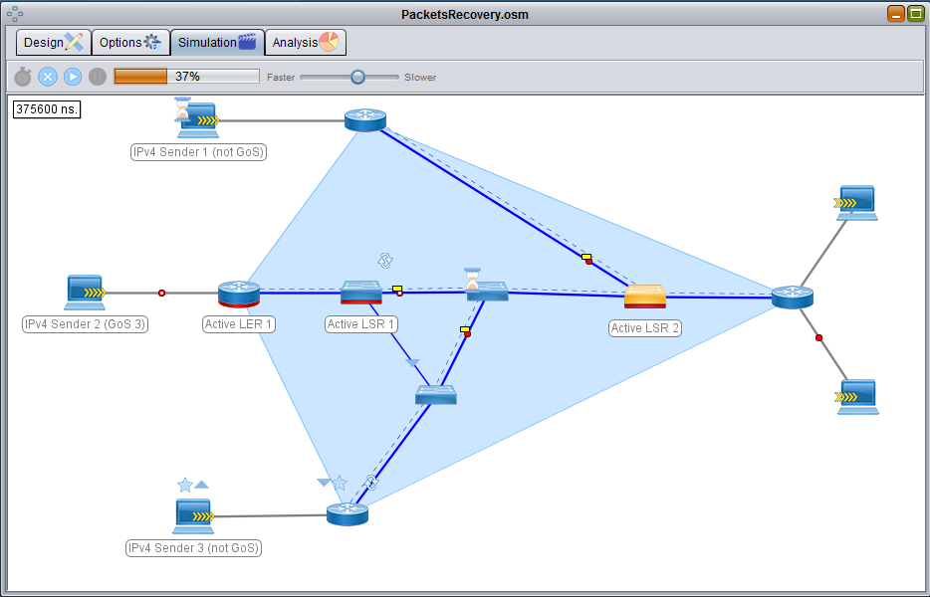

Show the progress of the simulation

The nodes show activity

Packets are shown circulating

This box shows at all times at what instant of the simulation we are

### Understanding the simulation

You can see a legend that explains all the symbols that you can see in the simulation. To make this legend appear, you must click with the main mouse button in the background of the simulation panel (click again to hide it).

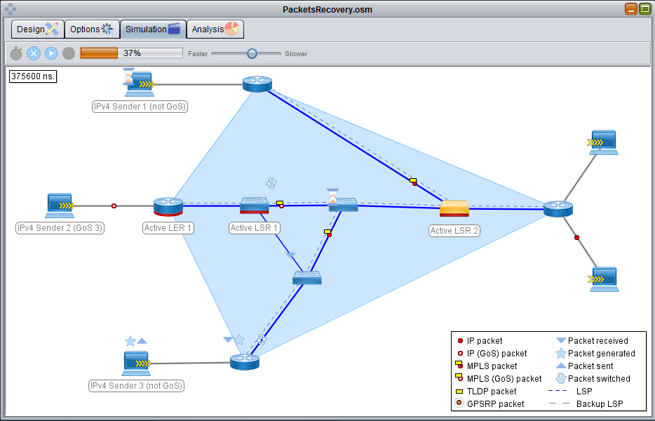

The legend explains all the usual aspects that you will see in the simulation

This hourglass means that the node is costing many nanoseconds to complete its task. Generally by a low switching power in relation to the task it has to perform.

### Interacting with the simulation

You can interact with the simulation in two ways:

* Manually causing congestion in a node.
* Making a link fail.

The simulation will adjust to the disasters you cause. This way you can analyze what happens in situations that could happen in reality.

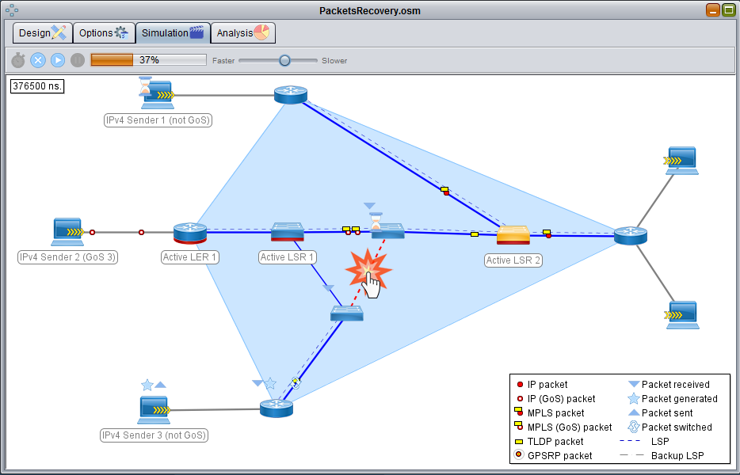

Click with the main mouse button on an active link to make this link fail.

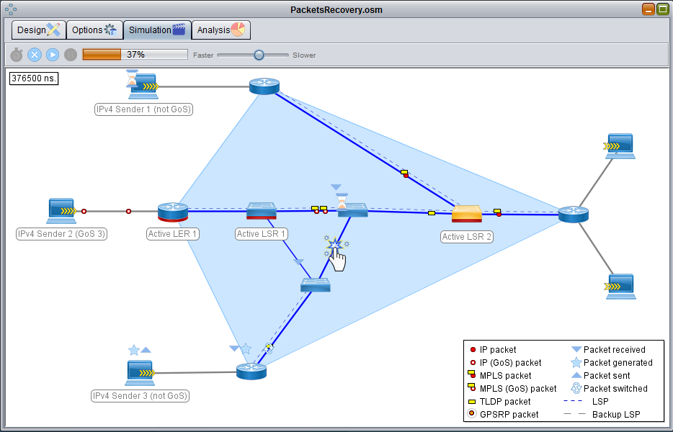

Click the left mouse button over a broken link to make this link recover.

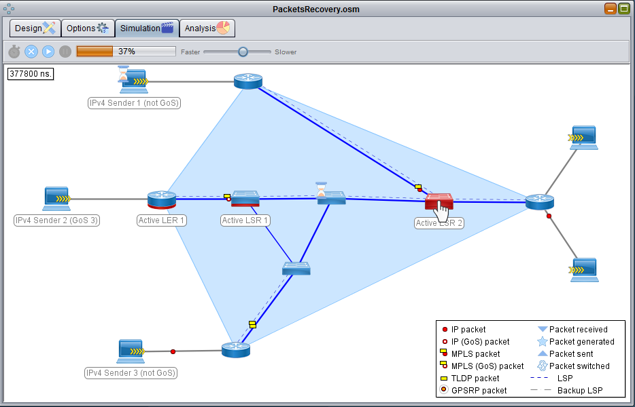

Click on a node so that its level of congestion rises to almost 100%. In this way you can simulate real congestion and see how the network responds.

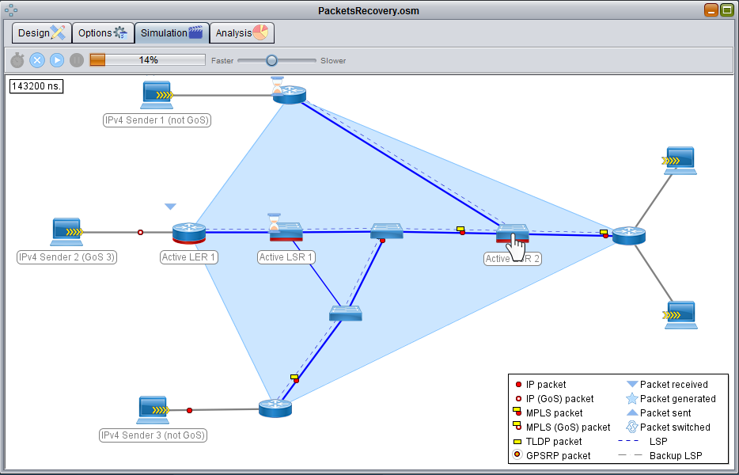

Click on a node that you have previously artificially congested so that its level of congestion returns to the real one.

## Step 4. Analyzing the simulation

After finishing the simulation (or while it is running) you can go to the "Analysis" tab to see the statistics of those elements that you have configured to generate them.

### Selection of the element to analyze

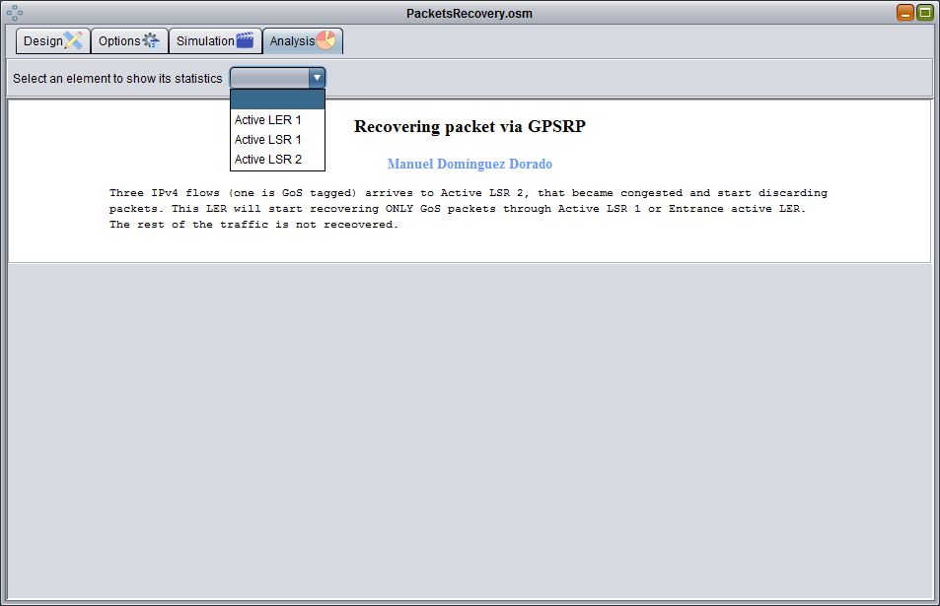

Select from this drop-down the element of your scenario that you want to analyze. If you did not configure an item to generate statistics in the "Design" tab, it will not appear here

The information about the scenario that you configured in the "Options" tab

### Statistical analysis

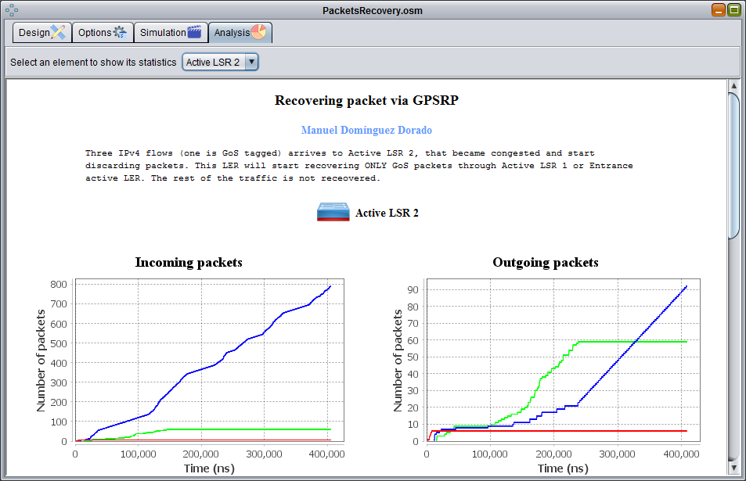

Charts. They vary in number and information depending on the type of element selected. If the simulation is not yet finished, you will see them in real time

Selected node

### Exporting charts

The graphics can be exported in PNG format to illustrate your work, practices ... in short, to reuse them where you see fit. You can also copy them to the clipboard and paste them directly elsewhere.

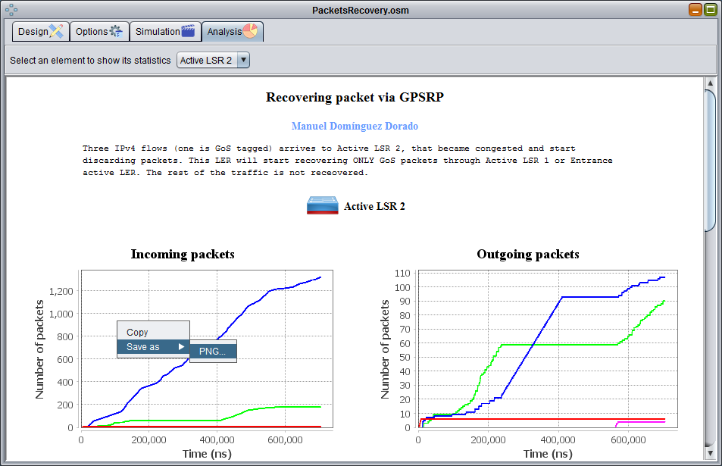

Clicking with the right button of the mouse allows to save the selected graphic in PNG format or copy it to the clipboard.

# Contribute

OpenSimMPLS is open source software. It is used by professionals and universities around the world (in more than 130 countries). It is a simulator in operation since 2004. Its maintenance is expensive in terms of time so, if you can contribute to its evolution/use, my family will thank you. There are many ways to collaborate.

## Teachers

As a teacher, you use this simulator in your practices regarding communication networks. You can contribute a lot:

* Contribute the **teaching units** you use, to teachers from other parts of the world. It is not necessary to provide the solutions, but the statements, the scenarios you use and the purpose of the practical session.
* **Encourage your students to contribute**, instilling in them from the beginning in class a collaborative culture and respect for the work of others. Not only will they learn more about MPLS networks, but they will learn to work with repositories of software versions, pull requests and collaborate on software development projects.

## Students

The students are very active. You are the people who directly use the simulator and, therefore, those who most discover their shortcomings. You can contribute a lot:

* **Contribute the scenarios that you develop** in your class practices.
* Contribute with **source code** **to repair bugs** or add new functionality.
* **Translate the simulator into other languages**. It is currently translated into Spanish and English, but any other language will be welcome. Together with them, Chinese and Arabic would allow practically anyone to understand it.
* **Build community.** Go to the OpenSimMPLS repository on GitHub: detect bugs, file issues for them, help answering questions from other users of the simulator, and so on.

## Researchers

Most researchers use OpenSimMPLS as the basis to develop your own techniques. You can contribute a lot in this regard:

* **Source code of algorithms or novel techniques** for the simulator. If it's already done, why not bring it?

## Professionals/developers

Professionals who use this simulator, get an economic benefit. I do not need financial resources, but time. **If your company uses this simulator, ask it to sponsor a few hours of your dedication to improve it**. It is the best way for you to have a simulator that is not obsolete.

Thanks for, at least, thinking about it ☺